队列的数组实现:
/*队列的数组实现*/
#include<iostream.h>
#define MAXSIZE 5
int front=-1,rear=-1;//队头及队尾指针
int Queue[MAXSIZE];//队列数组
int IsEmpty()//判空
{
if(front==-1&&rear==-1)
return 1;
else
return 0;
}
int IsFull()//判满
{
if(rear==MAXSIZE-1)
return 1;
else
return 0;
}
void EnQueue(int i)//入队
{
if(IsFull())
cout<<"队满，无法入队。"<<endl;
else
if(front==-1)
{
front++;
Queue[++rear]=i;
}
else
Queue[++rear]=i;
}
int DeQueue()//出队
{
if(IsEmpty())
{
cout<<"队空，无法出队。"<<endl;
return -1;
}
else
return Queue[front++];
}
void main()
{
for(int i=1;i<=6;i++)
EnQueue(i);
cout<<DeQueue()<<endl;
cout<<DeQueue()<<endl;
cout<<DeQueue()<<endl;
cout<<DeQueue()<<endl;
cout<<DeQueue()<<endl;
}
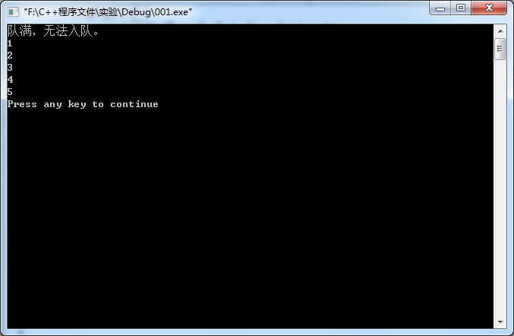
队列的链表实现:
/*队列的链表实现*/
#include<iostream.h>
struct Node
{
int num;
struct Node *next;
};
Node *front=NULL,*rear=NULL;//定义全局的头尾指针
void EnQueue(int i)//入链队
{
Node *newnode=new Node;
newnode->num=i;
if(front==NULL)
{
front=newnode;
rear=newnode;
newnode->next=NULL;
}
else
{
rear->next=newnode;
rear=newnode;
newnode->next=NULL;
}
}
int DeQueue()//出链队
{
int k;
Node *ptr;
if(front==NULL)
{
cout<<"栈空，无法出栈。"<<endl;
return -1;
}
else
{
ptr=front;
k=front->num;
front=front->next;
delete ptr;
return k;
}
}
void main()
{
for(int i=1;i<=5;i++)
EnQueue(i);
cout<<DeQueue()<<endl;
cout<<DeQueue()<<endl;
cout<<DeQueue()<<endl;
cout<<DeQueue()<<endl;
cout<<DeQueue()<<endl;
cout<<DeQueue()<<endl;
}
